May 22th , 2026

Database system
SWEG2108

College of Electrical and Mechanical Engineering
Department of Software Engineering

FOOD DELIVERY DATABASE SYSTEM: PROJECT REPORT

GROUP MEMBERS | ID
- AFOMIYA ASCHENAKI ETS 0111/17
- AKSAH ATLAW ETS 0121/17
- ARSEMA YESHIDNBER ETS 0199/17
- BEREKET DERESSE ETS 0262/17
- BETELHEM NURLACHEW ETS 0284/17
- BETELHEM SOLOMON ETS 0286/17
- MADING MAJOK ETS 1876/17

QuickBite — Intelligent Food Delivery System

Submitted To: Dr. Yaynshet Medhin Addis Ababa, Ethiopia

CHAPTER ONE: INTRODUCTION

1.1 Background of the Study
In the modern digital era, the rapid advancement of Information and Communication Technologies (ICT) has significantly transformed the way businesses operate, especially in the food service industry. Food delivery systems have evolved from simple telephone-based ordering methods into highly integrated, data-driven platforms. These platforms connect customers, restaurants, delivery personnel, and system administrators within a single digital environment, enabling faster and more efficient service delivery.
This transformation is largely driven by several real-world factors such as increasing urbanization, busy lifestyles, and the growing demand for convenience. Today, customers expect to order food anytime and from anywhere, making digital food delivery systems an essential part of everyday life. Behind these systems lies a large amount of data generated from various activities such as browsing menus, placing orders, making payments, and tracking deliveries.
The effectiveness of a food delivery system depends heavily on how well this data is managed. A poorly designed database can lead to delays, incorrect orders, and loss of important information. On the other hand, a well-structured database ensures smooth operations, accurate transactions, and better user experience.
Traditionally, relational databases such as MySQL have been used to manage structured data because of their reliability and strong consistency features (ACID properties). However, modern applications also require flexibility and scalability to handle large volumes of diverse data. This is where NoSQL databases like MongoDB become useful, as they allow storage of unstructured and semi-structured data in a flexible format.
This project focuses on designing and implementing a hybrid database system for a food delivery service using both MySQL and MongoDB. The aim is to combine the strengths of both approaches to build a system that is efficient, scalable, and suitable for real-world applications.

1.2 Problem Statement
Despite the rapid growth of food delivery platforms, many existing systems still face serious challenges related to data management and system performance. These issues are often caused by poor database design, lack of integration between system components, and inability to handle increasing amounts of data.
One major problem is data inconsistency, where the same information is stored in multiple places but not updated properly. For example, a customer’s address may be different in two tables, or menu prices may not be synchronized across the system. This creates confusion and affects the overall reliability of the system.
Another issue is scalability. As the number of users and transactions increases, systems that rely only on rigid relational structures may struggle to maintain performance. In addition, inefficient queries can slow down order processing, leading to delays and poor customer experience.
The key problems addressed in this project include:
- Data fragmentation and inconsistency between different system components
- Data redundancy due to poor database design
- Difficulty in managing complex relationships between entities
- Scalability limitations when handling large datasets
- Slow data retrieval affecting real-time operations
- Lack of effective reporting and analysis capabilities
This project aims to solve these challenges by designing a properly normalized relational database and integrating it with a flexible NoSQL database.

1.3 Project Motivation
The motivation behind this project goes beyond simply fulfilling academic requirements. It is based on understanding how important database systems are in real-life applications.
In a food delivery system, even a small error in the database can lead to serious consequences. For customers, it may result in receiving the wrong order or experiencing delays. For restaurants, it may lead to lost revenue and reduced customer trust. For delivery personnel, it may cause confusion and inefficiency in operations.
This project is therefore motivated by the need to design a system that is not only technically correct but also reliable and practical. It aims to bridge the gap between theoretical knowledge learned in class and its real-world application, ensuring that the system can support actual business needs.

1.4 Objectives of the Study

General Objective
The general objective of this project is to design and implement an efficient and scalable food delivery database system using both relational (MySQL) and non-relational (MongoDB) technologies.
Specific Objectives
To achieve the general objective, the project focuses on the following:
- To analyze the data requirements of a food delivery system
- To identify entities, attributes, and relationships involved in the system
- To design an Entity-Relationship (ER) diagram representing the system structure
- To develop a relational schema and normalize it up to Boyce-Codd Normal Form (BCNF)
- To implement the database using MySQL for structured data
- To implement MongoDB for flexible and scalable data storage
- To insert sample data and perform queries
- To generate reports for analysis and decision-making
- To evaluate system performance and efficiency

1.5 Scope and Delimitations
The scope of this project focuses mainly on the database design and implementation of a food delivery system. It includes the core functionalities required to manage the system effectively.
The system covers:
- Customer registration and profile management
- Restaurant and menu management
- Order placement and tracking
- Delivery personnel assignment
- Payment recording and management
However, the project has certain limitations, including:
- No development of a full web or mobile user interface
- No real-time GPS tracking (only simulated)
- No integration with real online payment systems
- Limited advanced analytics and recommendation features
These limitations are set to keep the focus on database design and ensure a clear understanding of data structures and relationships.

1.6 Significance of the Study
This project is important both academically and practically.
- From an academic perspective, it helps in applying database concepts such as ER modeling, normalization, and system design to a real-world problem. It also introduces the concept of using multiple database systems together.
- From a practical perspective, the system provides a foundation for building scalable and efficient food delivery applications. It demonstrates how proper database design can improve system performance and user experience.
The key benefits include:
- Better organization and management of data
- Reduction of data redundancy and inconsistency
- Improved efficiency in order processing
- Enhanced decision-making through reports
- Scalability to handle growing data
- Flexibility in managing different types of data

1.7 Methodology
This project follows a structured approach based on the Database Development Life Cycle (DDLC). Each stage is carefully executed to ensure a reliable system.
The main steps include:
- Requirement Analysis: Identifying system needs and data requirements
- Conceptual Design: Creating ER diagrams to represent entities and relationships
- Logical Design: Developing relational schema and applying normalization
- Implementation: Building the database using MySQL and MongoDB
- Testing and Evaluation: Checking system performance and correctness
This methodology ensures that the system is well-organized and meets its objectives.

1.8 Tools and Technologies Used
The following tools and technologies are used in this project:
- MySQL: For relational database implementation and structured data management
- MongoDB: For NoSQL database and flexible data storage
- Draw.io: For designing ER diagrams
- GitHub: For version control and collaboration
- Google Docs: For documentation and report preparation
CHAPTER 2: DATABASE DESIGN
This chapter presents the complete database design of the proposed hybrid food delivery management system. The design phase focuses on transforming the identified business requirements into a structured database model capable of supporting efficient data storage, retrieval, processing, and analysis. The chapter includes the Entity Relationship (ER) Diagram, Logical Schema Design, entity descriptions, attribute explanations, relationship analysis, normalization process, and input/output design considerations.
The database was designed using relational database principles to ensure data consistency, integrity, scalability, and reduced redundancy. The system integrates operational data such as customers, restaurants, orders, drivers, menu items, payments, loyalty programs, delivery predictions, and anomaly detection mechanisms into a unified structure.

2.1 Entity Relationship (ER) Diagram Description
The Entity Relationship Diagram (ERD) provides a conceptual representation of the food delivery database system. It illustrates the major entities involved in the system, their attributes, and the relationships established among them.
The ERD was designed to model real-world operations within a modern food delivery platform where customers place orders from restaurants, drivers deliver those orders, payments are processed digitally, loyalty systems reward customers, and predictive analytics improve delivery efficiency. The design contains multiple interconnected entities that collectively support operational processing, customer management, order tracking, delivery optimization, and analytical decision-making.
ER Diagram
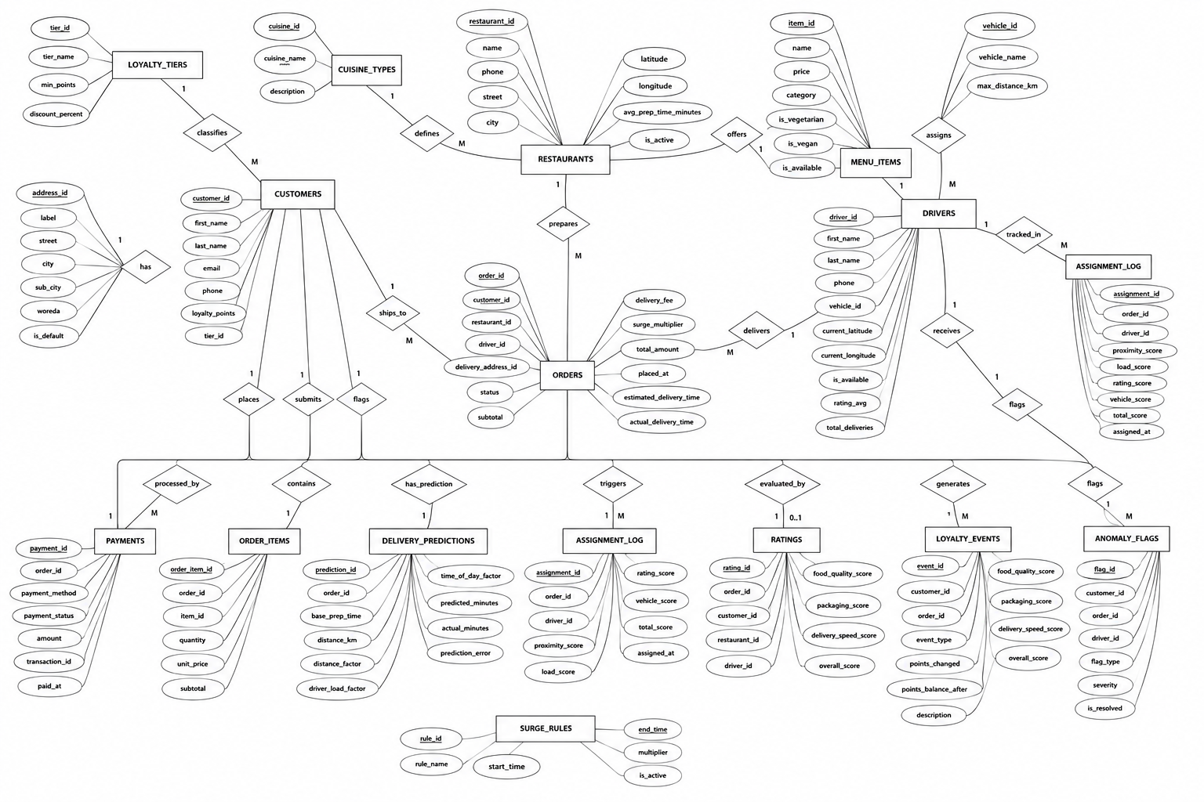Zoom the picture to get a better view of the diagram!!!

2.2 Description of Major Entities

2.2.1 CUSTOMERS Entity
- The CUSTOMERS entity stores all information related to users who place food orders through the platform.

Attributes of CUSTOMERS
Attribute | Description
customer_id | Unique identifier for each customer
first_name | Customer’s first name
last_name | Customer’s surname
email | Customer email address
phone | Customer contact number
loyalty_points | Accumulated reward points
tier_id | Foreign key linking customer to loyalty tier

Purpose of the Entity
- This entity serves as the central user management component of the system. It enables customer authentication, order tracking, loyalty management, and customer analytics.

Relationships
- One customer can have many addresses.
- One customer can place many orders.
- One customer can submit many ratings.
- One customer can generate many loyalty events.
- One customer may be associated with anomaly flags.

2.3.2 ADDRESSES Entity
- The ADDRESSES entity stores delivery location details for customers.

Attributes of ADDRESSES
Attribute | Description
address_id | Unique identifier for address
customer_id | References customer owner
label | Address nickname (Home, Office, etc.)
street | Street name
city | City name
sub_city | Sub-city or district
woreda | Administrative area
is_default | Indicates default delivery address

Purpose
- This entity supports multiple delivery locations for a single customer, improving convenience and delivery flexibility.

Relationship
- One customer can have many addresses.
- One address may be used in multiple orders.

2.2.3 LOYALTY_TIERS Entity
- The LOYALTY_TIERS entity manages customer membership classifications.

Attributes of LOYALTY_TIERS
Attribute | Description
tier_id | Unique loyalty tier identifier
tier_name | Tier category name
min_points | Minimum required points
discount_percent | Discount assigned to tier

Purpose
- The entity supports customer retention strategies by rewarding frequent users with discounts and benefits.

Relationship
- One loyalty tier can classify many customers.

2.2.4 RESTAURANTS Entity
- The RESTAURANTS entity stores information about restaurants registered on the platform.

Attributes of RESTAURANTS
Attribute | Description
restaurant_id | Unique restaurant identifier
name | Restaurant name
cuisine_id | References cuisine category
phone | Restaurant contact number
street | Street location
city | City name
latitude | GPS latitude
longitude | GPS longitude
is_active | Availability status
avg_prep_time_minutes | Average food preparation time

Purpose
- This entity enables restaurant registration, order preparation tracking, and menu management.

Relationships
- One cuisine type can define many restaurants.
- One restaurant can offer many menu items.
- One restaurant can prepare many orders.

2.2.5 CUISINE_TYPES Entity
- This entity categorizes restaurants according to food specialization.

Attributes of CUISINE_TYPES
Attribute | Description
cuisine_id | Unique cuisine identifier
cuisine_name | Cuisine category
description | Description of cuisine

Purpose
- Cuisine classification improves customer search experience and restaurant categorization.

Relationship
- One cuisine type can be associated with many restaurants.

2.2.6 MENU_ITEMS Entity
- The MENU_ITEMS entity stores food products offered by restaurants.

Attributes of MENU_ITEMS
Attribute | Description
item_id | Unique menu item identifier
restaurant_id | References restaurant
name | Item name
price | Item price
category | Food category
is_vegetarian | Vegetarian indicator
is_vegan | Vegan indicator
is_available | Availability status

Purpose
- This entity enables menu display, pricing management, and dietary filtering.

Relationships
- One restaurant can have many menu items.
- One menu item may appear in many order items.

2.2.7 ORDERS Entity
- The ORDERS entity represents customer purchase transactions.

Purpose
- This is the core transactional entity of the system. It coordinates customer purchases, restaurant preparation, driver delivery, payment processing, and tracking operations.

Relationships
- One customer can place many orders.
- One restaurant can prepare many orders.
- One driver can deliver many orders.
- One order can contain many order items.
- One order can have one payment.
- One order can generate assignment logs and delivery predictions.

Attributes of ORDERS
Attribute | Description
order_id | Unique order identifier
customer_id | References customer
restaurant_id | References restaurant
driver_id | References assigned driver
delivery_address_id | References delivery address
rule_id | References surge pricing rule
status | Current order status
subtotal | Cost before fees
delivery_fee | Delivery charge
surge_multiplier | Dynamic pricing multiplier
total_amount | Final payable amount
placed_at | Order placement time
estimated_delivery_time | Estimated delivery time
actual_delivery_time | Actual delivery completion time

2.2.8 ORDER_ITEMS Entity
- This entity stores detailed products contained in an order.

Attributes of ORDER_ITEMS
Attribute | Description
order_item_id | Unique identifier
order_id | References order
item_id | References menu item
quantity | Ordered quantity
unit_price | Price per item
subtotal | Calculated subtotal

Purpose
- It resolves the many-to-many relationship between orders and menu items.

Relationship
- One order contains many order items.
- One menu item may exist in many order items.

2.2.9 DRIVERS Entity
- The DRIVERS entity stores delivery personnel information.

Attributes of DRIVERS
Attribute | Description
driver_id | Unique driver identifier
first_name | Driver first name
last_name | Driver last name
phone | Driver contact number
vehicle_id | Assigned vehicle type
current_latitude | Current GPS latitude
current_longitude | Current GPS longitude
is_available | Driver availability
rating_avg | Average driver rating
total_deliveries | Total completed deliveries

Purpose
- This entity supports delivery assignment, location tracking, and performance monitoring.

Relationships
- One vehicle type can be assigned to many drivers.
- One driver can deliver many orders.
- One driver can receive many ratings.
- One driver can appear in assignment logs.

2.2.10 VEHICLE_TYPES Entity
- The VEHICLE_TYPES entity defines transportation categories.

Attributes of VEHICLE_TYPES
Attribute | Description
vehicle_id | Unique vehicle identifier
vehicle_name | Vehicle category
max_distance_km | Maximum delivery distance

Purpose
- This entity improves delivery optimization by matching vehicles to delivery requirements.

Relationship
- One vehicle type can be used by many drivers.

2.2.11 PAYMENTS Entity
- The PAYMENTS entity stores transaction and payment details.

Attributes of PAYMENTS
Attribute | Description
payment_id | Unique payment identifier
order_id | References order
payment_method | Method of payment
payment_status | Payment state
amount | Paid amount
transaction_id | Digital transaction reference
paid_at | Payment timestamp

Purpose
- This entity ensures secure financial transaction recording and payment verification.

Relationship
- One order is processed by one payment record.

2.2.12 RATINGS Entity
- The RATINGS entity stores customer feedback after order completion.

Attributes of RATINGS
Attribute | Description
rating_id | Unique rating identifier
order_id | References order
customer_id | References customer
restaurant_id | References restaurant
driver_id | References driver
food_quality_score | Food quality rating
packaging_score | Packaging rating
delivery_speed_score | Delivery speed rating
overall_score | Overall experience score

Purpose
- This entity supports service quality evaluation and customer satisfaction analysis.

Relationships
- One customer can submit many ratings.
- One driver can receive many ratings.
- One order may have one rating.

2.2.13 DELIVERY_PREDICTIONS Entity
- The DELIVERY_PREDICTIONS entity stores analytical delivery estimation information.

Attributes of DELIVERY_PREDICTIONS
Attribute | Description
prediction_id | Unique prediction identifier
order_id | References order
base_prep_time | Initial preparation estimate
distance_km | Delivery distance
distance_factor | Distance impact factor
driver_load_factor | Driver workload factor
time_of_day_factor | Traffic/time influence
predicted_minutes | Estimated delivery time
actual_minutes | Actual completion time
prediction_error | Difference between prediction and actual result

Purpose
- This entity enables predictive analytics and delivery optimization.

Relationship
- One order can have one delivery prediction record.

2.2.14 ASSIGNMENT_LOG Entity
- The ASSIGNMENT_LOG entity records driver assignment evaluation metrics.

Attributes of ASSIGNMENT_LOG
Attribute | Description
assignment_id | Unique assignment identifier
order_id | References order
driver_id | References driver
proximity_score | Distance suitability score
load_score | Driver workload score
rating_score | Driver performance score
vehicle_score | Vehicle suitability score
total_score | Final calculated assignment score
assigned_at | Assignment timestamp

Purpose
- This entity improves delivery dispatch efficiency and transparency.

Relationships
- One order can generate many assignment logs.
- One driver can appear in many assignment logs.

2.2.15 LOYALTY_EVENTS Entity
- The LOYALTY_EVENTS entity records customer reward activities.

Attributes of LOYALTY_EVENTS
Attribute | Description
event_id | Unique event identifier
customer_id | References customer
order_id | References order
event_type | Reward activity type
points_changed | Points gained or deducted
points_balance_after | Updated points balance
description | Event description

Purpose
- This entity tracks loyalty program transactions and customer reward history.

Relationship
- One customer can generate many loyalty events.

2.2.16 ANOMALY_FLAGS Entity
- The ANOMALY_FLAGS entity records suspicious or abnormal activities.

Attributes of ANOMALY_FLAGS
Attribute | Description
flag_id | Unique anomaly identifier
customer_id | References customer
order_id | References order
driver_id | References driver
flag_type | Type of anomaly
severity | Risk severity
is_resolved | Resolution status

Purpose
- This entity enhances security, fraud detection, and operational monitoring.

Relationships
- One customer may have many anomaly flags.
- One driver may have many anomaly flags.
- One order may generate many anomaly records.

2.4 Relationship Analysis
- The database contains several one-to-many relationships that ensure efficient normalization and data integrity.

Major Relationships
Relationship | Cardinality
LOYALTY_TIERS → CUSTOMERS | One-to-Many
CUSTOMERS → ADDRESSES | One-to-Many
CUSTOMERS → ORDERS | One-to-Many
RESTAURANTS → MENU_ITEMS | One-to-Many
RESTAURANTS → ORDERS | One-to-Many
DRIVERS → ORDERS | One-to-Many
ORDERS → ORDER_ITEMS | One-to-Many
MENU_ITEMS → ORDER_ITEMS | One-to-Many
ORDERS → PAYMENTS | One-to-One
ORDERS → DELIVERY_PREDICTIONS | One-to-One
CUSTOMERS → RATINGS | One-to-Many
DRIVERS → RATINGS | One-to-Many
ORDERS → ASSIGNMENT_LOG | One-to-Many
- The relationships were carefully designed to eliminate redundancy while preserving accurate data associations.

2.5 Logical Schema Design
- The logical schema translates the ER diagram into relational tables consisting of primary keys and foreign keys.
The schema ensures:
- Entity integrity through primary keys
- Referential integrity through foreign keys
- Reduced redundancy
- Efficient query execution
- Proper normalization
The logical schema includes all operational and analytical components required by the food delivery platform.
- The ORDERS table acts as the central transactional table connected to customers, restaurants, drivers, addresses, payments, and predictive modules.
- The ORDER_ITEMS table resolves the many-to-many relationship between orders and menu items.
- Analytical entities such as DELIVERY_PREDICTIONS, ASSIGNMENT_LOG, and ANOMALY_FLAGS support intelligent system functionalities including predictive analytics, automated driver assignment, and fraud monitoring.
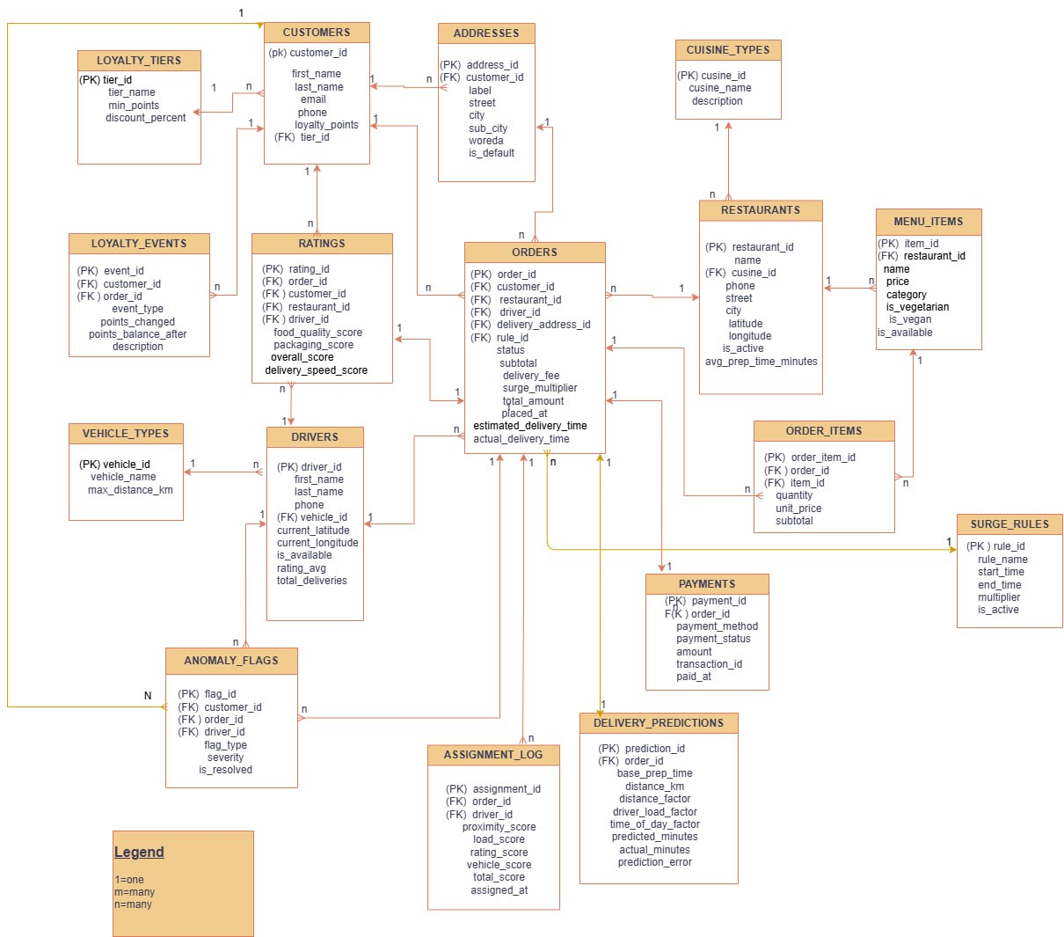
Zoom the picture to get a better view of the diagram!!!

Normalization Process
- Normalization is a database design technique used to organize data properly by reducing redundancy and eliminating anomalies. In the development of the QuickBite Intelligent Food Delivery System database, normalization was performed carefully from the unnormalized stage up to Boyce-Codd Normal Form (BCNF).
- During the early design stage of the system, most of the information was initially imagined inside a few large tables because it looked simpler to manage. However, after analyzing the data more closely, several problems became noticeable. Customer information was repeated many times, restaurant details appeared in multiple records, and order items were stored using repeating columns. If the system had been implemented in that structure, it would have created serious consistency and maintenance problems later.
- To avoid these issues, the database was normalized step by step. At every stage, functional dependencies were analyzed, unnecessary repetition was removed, and separate relations were created where needed. The normalization process also helped improve scalability and maintain data integrity throughout the system.
The following subsections explain the complete normalization process in detail.

2.6.1 Unnormalized Form (UNF)
- Before normalization, the system data could be represented in one large table containing customer details, restaurant information, ordered items, payment information, delivery information, and rating details all together. This type of structure is common in the early stages of design before proper normalization is applied.

RAW_ORDER_DATA
Attribute | Description
order_id | Unique order identifier
customer_name | Name of customer
customer_phone | Customer phone number
customer_email | Customer email
customer_address | Delivery address
loyalty_tier | Customer loyalty tier
restaurant_name | Restaurant name
restaurant_phone | Restaurant contact
cuisine_type | Restaurant cuisine
item_1_name | First ordered item
item_1_price | Price of first item
item_1_qty | Quantity of first item
item_2_name | Second ordered item
item_2_price | Price of second item
item_2_qty | Quantity of second item
driver_name | Delivery driver
vehicle_type | Vehicle used
payment_method | Payment method
payment_amount | Amount paid
order_status | Current order status
order_date | Date of order

Problems Identified in UNF
After analyzing the table structure, several problems were identified.

1. Repeating Groups
The item columns such as:
- item_1_name
- item_2_name
- item_3_name
created repeating groups. Since an order may contain any number of items, storing them using fixed columns was not practical.

2. Data Redundancy
- Customer details were repeated for every order. For example, if a customer placed 20 different orders, the same customer phone number and email would appear 20 times.
- Restaurant details also suffered from the same problem.

3. Update Anomaly
- If a restaurant changed its phone number, every row containing that restaurant would need to be updated manually. Missing even one row would create inconsistent data.

4. Insertion Anomaly
- A new menu item could not be added unless an order already existed containing that item.
- Similarly, a new restaurant could not be inserted properly without associated order data.

5. Deletion Anomaly
- Deleting an order could accidentally remove important customer or restaurant information from the system.
For example, deleting the only order belonging to a customer could result in losing the customer's contact details as well.
- Because of these problems, the database structure required normalization.

2.6.2 First Normal Form (1NF)

Definition of 1NF
A relation is in First Normal Form when:
- Each attribute contains atomic values
- Repeating groups are removed
- Every row is uniquely identifiable using a primary key
The main goal of 1NF is to eliminate repeating attributes and ensure that each column stores only one value.

Conversion from UNF to 1NF
- To achieve 1NF, the repeating item columns were removed from the original table structure. Instead of storing ordered items in separate columns, each ordered item was stored as a separate row.
- At first, we considered keeping item details together inside the order table because it looked easier during data entry. However, after discussing how orders with many items would behave, we realized that storing items as rows would make the database more flexible and easier to query later.

Tables Created in 1NF

Table: ORDERS_1NF

- order_id (PK)
- customer_id
- restaurant_id
- driver_id
- payment_method
- total_amount
- order_status
- order_date

Primary Key: order_id

Table: ORDER_ITEMS_1NF
order_id | item_seq | item_name | item_price | quantity
101 | 1 | Pizza | 250 | 2
101 | 2 | Coke | 40 | 1
102 | 1 | Burger | 180 | 1
order_id | item_seq | item_name | item_price | quantity
Primary Key: (order_id, item_seq)

Improvements Achieved in 1NF
After applying 1NF:
- Repeating item groups were removed
- Each attribute contained only atomic values
- Orders could contain any number of items
- Primary keys were properly defined
- Although the structure improved significantly, some dependency problems still remained.
For example: item_name and item_price did not depend on the whole composite key (order_id, item_seq).
- This resulted in partial dependency, which needed to be solved in the next normalization stage.

2.6.3 Second Normal Form (2NF)

Definition of 2NF
A relation is in Second Normal Form when:
- It is already in 1NF
- Every non-key attribute depends on the entire primary key
- No partial dependency exists
Partial dependency mainly occurs in relations that use composite primary keys.

Partial Dependency Identified
In the table:
- ORDER_ITEMS_1NF(order_id, item_seq, item_name, item_price, quantity)
- The primary key was: (order_id, item_seq)
However:
- item_name
- item_price
Depended only on the item itself and not on the full composite key. This meant that the table violated 2NF.

Functional Dependency Analysis
The following dependencies were identified:
- (order_id, item_seq) → quantity
- item_id → item_name, item_price
Since item_name and item_price depended only on item_id, they needed to be separated into another relation.

Conversion to 2NF
To eliminate the partial dependency:
- Item details were removed from ORDER_ITEMS
- A separate MENU_ITEMS table was created
- ORDER_ITEMS retained only transactional data

Tables After Applying 2NF

Table: MENU_ITEMS
item_id | item_name | item_price
1 | Pizza | 250
2 | Coke | 40
3 | Burger | 180
item_id | item_name | item_price
Primary Key: item_id

Table: ORDER_ITEMS
order_id | item_id | quantity | subtotal
101 | 1 | 2 | 500
101 | 2 | 1 | 40
102 | 3 | 1 | 180
Primary Key: (order_id, item_id)
Foreign Keys: order_id → ORDERS(order_id) , item_id → MENU_ITEMS(item_id)

Additional 2NF Improvements
During dependency analysis, we also realized that customer information was unnecessarily repeated in the ORDERS table.
Attributes such as:
- customer_name
- customer_phone
- customer_email
Depended only on customer_id., because of this, a separate CUSTOMERS table was introduced.

Table: CUSTOMERS
customer_id | first_name | last_name | email | phone
Primary Key: customer_id
This reduced redundancy and simplified future updates involving customer information.

2.6.4 Third Normal Form (3NF)

Definition of 3NF
A relation is in Third Normal Form when:
- It is already in 2NF
- No transitive dependency exists
A transitive dependency occurs when a non-key attribute depends on another non-key attribute instead of directly depending on the primary key.

Transitive Dependency Identified
One important transitive dependency appeared in the customer loyalty structure.
Initially, the customer table contained:
- loyalty_tier
- discount_percent
The dependency looked like this:
- customer_id → tier_id → discount_percent
This meant that discount_percent depended on tier_id, not directly on customer_id.
If discount percentages changed in the future, many customer records would need to be updated.

Conversion to 3NF
To remove the transitive dependency, a separate LOYALTY_TIERS table was created.

Table: LOYALTY_TIERS
tier_id | tier_name | min_points | discount_percent
1 | Bronze | 0 | 0
2 | Silver | 500 | 5
3 | Gold | 1000 | 10
Primary Key: tier_id

Updated CUSTOMERS Table
customer_id | first_name | last_name | email | phone | loyalty_points | tier_id
Foreign Key: tier_id → LOYALTY_TIERS(tier_id)

Other Transitive Dependencies Removed

Restaurant Information
Originally, restaurant details such as:
- restaurant_name
- restaurant_phone
- cuisine_type were stored inside the ORDERS table.
These attributes depended on restaurant_id, not on order_id.
To solve this issue, a separate RESTAURANTS table was created.

Driver Information
Driver-related information including:
- driver_name
- vehicle_type also depended on driver_id.
As a result:
- DRIVERS table
- VEHICLE_TYPES table were created separately.

Address Information
- During normalization, we also discussed whether customer addresses should remain inside the ORDERS table. Finally, we decided to separate them into an ADDRESSES table because one customer may use multiple delivery addresses over time.
- This design also improved scalability for future expansion.

Final ORDERS Table After 3NF
Attribute
order_id
customer_id
restaurant_id
driver_id
delivery_address_id
subtotal
delivery_fee
total_amount
order_status
placed_at
- At this stage, every non-key attribute depended directly on the primary key.
- All identified transitive dependencies had been removed successfully.

2.6.5 Boyce-Codd Normal Form (BCNF)

Definition of BCNF
- BCNF is a stricter version of Third Normal Form.
- For every functional dependency: X → Y
- X must be a superkey.
- In simple terms, every determinant must be a candidate key.

BCNF Verification Process
- After completing 3NF, all relations were analyzed individually to determine whether any non-superkey determinants still existed.
- Most relations already satisfied BCNF naturally because they had simple primary keys and properly separated dependencies.

Example 1: CUSTOMERS Relation
Candidate Keys:
- customer_id
- email
Functional Dependencies:
- customer_id → first_name, last_name, email, phone, loyalty_points, tier_id
- email → customer_id, first_name, last_name, phone, loyalty_points, tier_id
Since both determinants are candidate keys, the relation satisfies BCNF.

Example 2: ORDER_ITEMS Relation
Candidate Key:
- (order_id, item_id)
Functional Dependency:
- (order_id, item_id) → quantity, subtotal
The determinant itself is the candidate key, therefore no BCNF violation exists.

Example 3: RATINGS Relation
Candidate Key:
- rating_id
We checked whether dependencies such as: order_id → restaurant_id existed inside the relation.
After analyzing the table structure, we concluded that the dependency does not hold within RATINGS because restaurant information is stored independently. Therefore, the relation satisfies BCNF.

Example 4: ASSIGNMENT_LOG Relation
Candidate Key:
- assignment_id
- We also examined whether: order_id → driver_id could create a dependency problem.
However, one order may be reassigned to multiple drivers, meaning order_id does not uniquely determine driver_id. Because of this, no BCNF violation exists.

BCNF Verification Summary
Relation | Candidate Key(s) | BCNF Status
customers | customer_id, email | ✅ Satisfied
addresses | address_id | ✅ Satisfied
loyalty_tiers | tier_id | ✅ Satisfied
loyalty_events | event_id | ✅ Satisfied
restaurants | restaurant_id | ✅ Satisfied
cuisine_types | cuisine_id | ✅ Satisfied
menu_items | item_id | ✅ Satisfied
orders | order_id | ✅ Satisfied
order_items | (order_id, item_id) | ✅ Satisfied
drivers | driver_id | ✅ Satisfied
vehicle_types | vehicle_id | ✅ Satisfied
payments | payment_id | ✅ Satisfied
ratings | rating_id | ✅ Satisfied
delivery_predictions | prediction_id | ✅ Satisfied
assignment_log | assignment_id | ✅ Satisfied
anomaly_flags | flag_id | ✅ Satisfied
surge_rules | rule_id | ✅ Satisfied
Based on the dependency analysis performed during database design, the complete QuickBite schema satisfies BCNF requirements.

2.6.6 Benefits Achieved Through Normalization
The normalization process provided several important benefits to the QuickBite system.

Reduced Redundancy:- Customer, restaurant, and driver details are stored only once instead of being repeated across many orders.

Better Data Integrity:- Foreign key constraints ensure that every order references valid records. This prevents inconsistent or orphaned data.

Easier Maintenance:- Updates become much simpler. For example, changing a restaurant phone number requires modifying only one record.

Reduced Anomalies:- Insertion, deletion, and update anomalies were minimized significantly after normalization.

Improved Scalability:- The database structure became more organized and scalable for future system expansion.

Better Query Management:- Smaller and more focused tables improve indexing efficiency and analytical query performance.

CHAPTER 3: IMPLEMENTATION

3.1 Database Creation and Table Structure
The QuickBite database was implemented using MySQL Workbench. All 17 tables were successfully created including core business tables, intelligence tables and reference/lookup tables. The following screenshot shows the complete table structure in the left panel of MySQL Workbench.
All 17 Tables in quickbite_db (MySQL Workbench)”
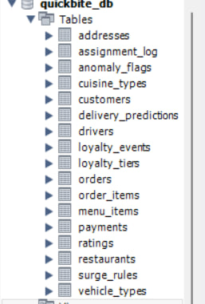

- Result: All 17 tables created successfully — addresses, assignment_log, anomaly_flags, cuisine_types, customers, delivery_predictions, drivers, loyalty_events, loyalty_tiers, menu_items, orders, order_items, payments, ratings, restaurants, surge_rules, and vehicle_types.

3.2 Database Views
Four views were created to simplify complex queries and provide ready-made analytical reports. Each view joins multiple tables and returns a comprehensive result set in a single query.

3.2.1. Driver Performance View (vw_driver_performance)
The following screenshot shows the result of querying the vw_driver_performance view, which combines driver data with ratings and assignment logs to produce a full driver performance report including average speed scores, behavior scores and assignment scores.
vw_driver_performance View Result:
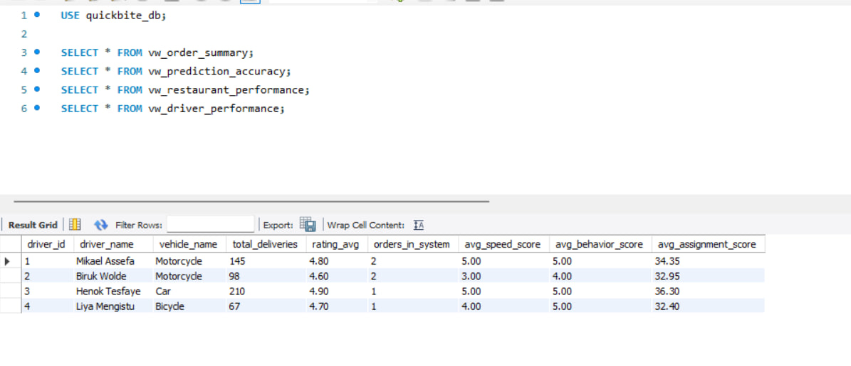
- Result: All 4 drivers returned with total deliveries, average rating, orders in system, average speed score, average behavior score and average assignment score successfully calculated.

3.3 Stored Procedures
Three stored procedures were implemented to handle the core business logic of the system: driver assignment, delivery time prediction and anomaly detection. All three procedures were called and tested successfully.

3.3.1 . Procedure 1 — sp_assign_best_driver
This procedure scores all available drivers based on four factors — proximity to restaurant, current load, rating average and vehicle type — and automatically assigns the highest scoring driver to the order. The following screenshot shows the procedure being called for order 5.
sp_assign_best_driver Result for Order 5”

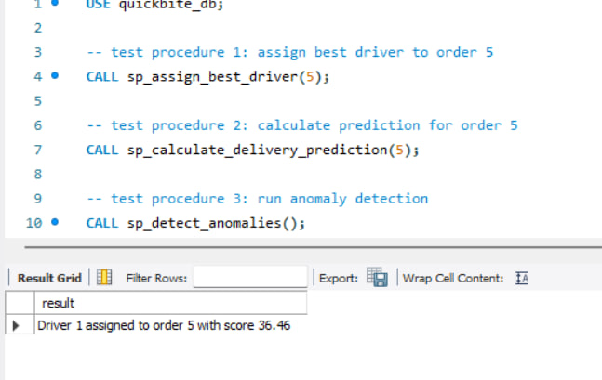

- Result: "Driver 1 assigned to order 5 with score 36.46" — Mikael Assefa was selected as the best available driver based on proximity, load, rating and vehicle scoring.

3.3.2 Procedure 2 — sp_calculate_delivery_prediction
This procedure calculates the estimated delivery time for an order using four factors: base restaurant preparation time, distance factor, driver load factor and time-of-day factor. Each factor is stored separately in the delivery_predictions table for future accuracy analysis.
sp_calculate_delivery_prediction Result for Order 5
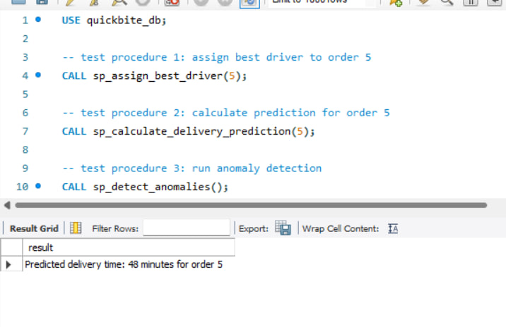

- Result: "Predicted delivery time: 48 minutes for order 5" — the prediction was calculated using all four factors and stored in the delivery_predictions table along with the estimated delivery timestamp.

3.3.3 Procedure 3 — sp_detect_anomalies
This procedure scans all orders for suspicious patterns including high refund rates, rapid duplicate orders and abnormal order values. Any detected anomalies are automatically inserted into the anomaly_flags table with a severity rating for management review.
sp_detect_anomalies Result
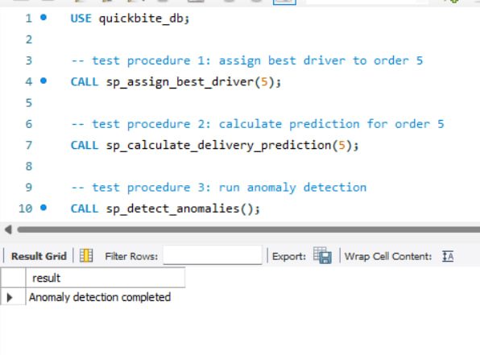
Result: "Anomaly detection completed" — the procedure successfully scanned all orders and flagged suspicious records in the anomaly_flags table.

3.4 Triggers
Three triggers were implemented to automate key business processes without requiring manual SQL. The trigger test below demonstrates trg_after_order_delivered — which automatically adds loyalty points to a customer and increments the driver delivery count the moment an order is marked as delivered.

3.4.1 Trigger Test — trg_after_order_delivered
The following two screenshots show customer 5 (Yonas Girma) BEFORE and AFTER order 5 was marked as delivered. The trigger fired automatically when the order status was updated.
Customer 5 Loyalty Points BEFORE Trigger (points: 900, tier: 2):
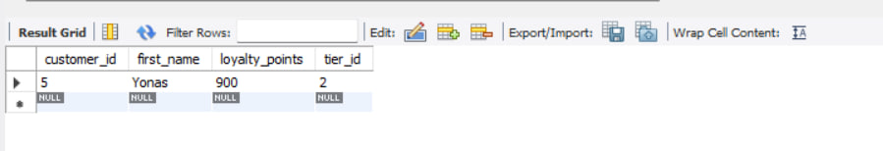

Customer 5 Loyalty Points AFTER Trigger (points: 929, tier: 2)
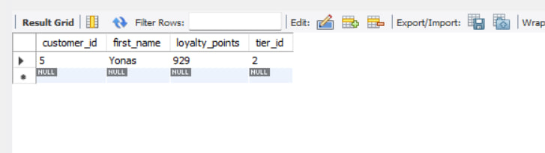

- Result: Loyalty points automatically increased from 900 to 929 (29 points = 10% of order total 290 ETB). No manual SQL was executed — the trigger handled everything automatically.

3.4.2 Loyalty Event Auto-Logged by Trigger
The trigger also automatically inserted a record into the loyalty_events table recording the points earned, the balance after, and the order reference. The following screenshot confirms this.
Loyalty Event Automatically Inserted by Trigger
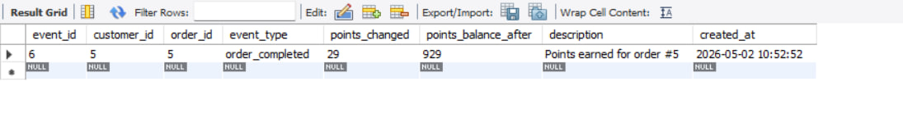
- Result: Event type "order_completed" automatically logged for customer 5, order 5 with 29 points earned and new balance of 929 points recorded.

3.4.3 Driver Delivery Count Auto-Updated by Trigger
The same trigger also incremented the driver's total_deliveries count automatically. Driver 1 (Mikael Assefa) had 145 deliveries before — the trigger updated it to 146.
Driver 1 Total Deliveries Auto-Incremented by Trigger
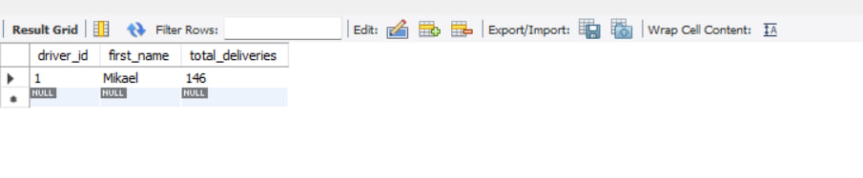
- Result: Driver Mikael Assefa's total_deliveries automatically updated from 145 to 146 when order 5 was marked delivered no manual update required.

3.5 Advanced Analytical Queries
Seven advanced analytical queries were implemented to demonstrate the intelligence and reporting capabilities of the QuickBite system. These queries use JOINs, GROUP BY, CASE statements, window functions and subqueries.

Query 1 — Overall Delivery Prediction Accuracy Report
This query analyzes all completed delivery predictions and groups them by accuracy rating (Excellent, Good, Fair, Poor). It also calculates the overall average accuracy percentage across all orders.
Prediction Accuracy Report
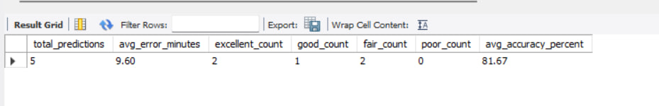
- Result: 5 total predictions analyzed — 2 Excellent, 1 Good, 2 Fair, 0 Poor. Average accuracy: 81.67%. Average error: 9.6 minutes. This confirms the delivery prediction engine is performing well.

Query 2 — Driver Assignment Score Breakdown
This query shows the full scoring breakdown for every driver assignment decision — proximity score, load score, rating score, vehicle score and total score. This makes the assignment logic fully transparent and auditable.
Driver Assignment Score Breakdown
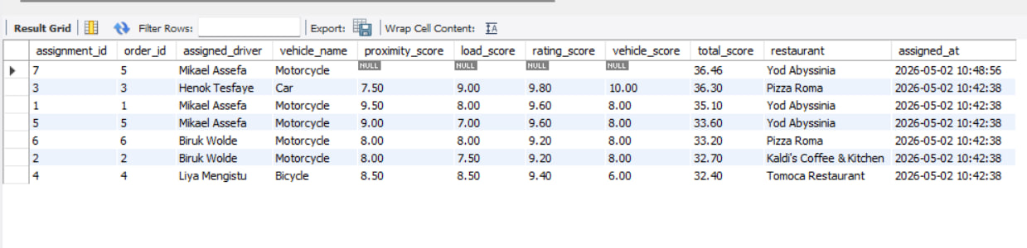
- Result: All 7 assignment records returned with full score breakdown per driver. Mikael Assefa scored highest (36.46) for order 5 and Henok Tesfaye scored highest (36.30) for order 3 due to vehicle type advantage.

Query 3 — Revenue Report with Surge Pricing Analysis
This query compares revenue generated under normal pricing versus surge pricing periods, showing the impact of the surge pricing engine on delivery fees and total revenue.
Revenue Report with Surge Analysis
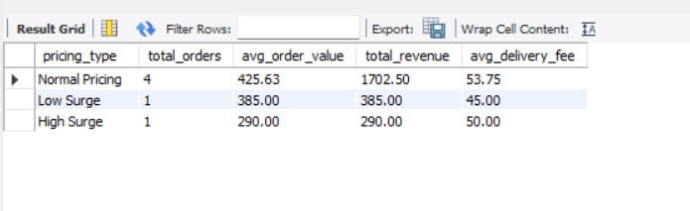
- Result: Normal pricing generated 1702.50 ETB across 4 orders. Low surge (1.20x) generated 385.00 ETB. High surge (1.50x) generated 290.00 ETB from 1 order showing the multiplier effect on revenue.

Query 4 — Customer Loyalty Report
This query shows every customer's current loyalty tier, points balance, how many points they need to reach the next tier, and their total spending history.
Customer Loyalty Report
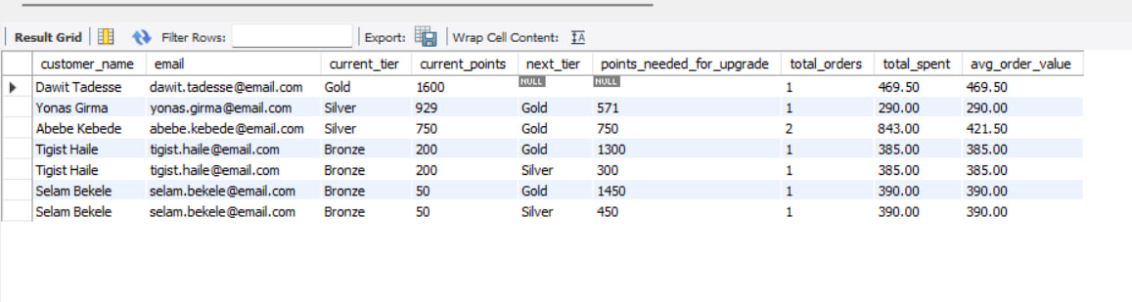
- Result: All 5 customers returned with tier status, current points, next tier name and points needed for upgrade. Dawit Tadesse is already Gold tier with 1600 points and no further upgrades available.

Query 5 — Restaurant Performance Ranking
This query ranks all restaurants by total revenue and average rating using SQL window functions (RANK OVER). It provides a complete performance comparison across all restaurants in the system.
Restaurant Performance Ranking
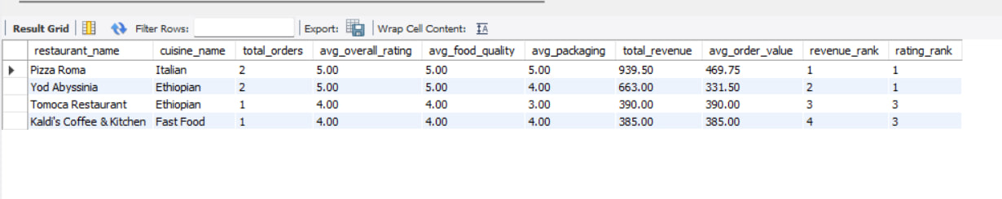
- Result: Pizza Roma ranked 1st by revenue (939.50 ETB) and 1st by rating (5.00). Yod Abyssinia ranked 2nd by revenue. Both Pizza Roma and Yod Abyssinia share the top rating rank of 1.

Query 6 — Anomaly Flags Summary Report
This query summarizes all anomaly flags grouped by severity and type, showing how many are resolved vs unresolved. This serves as a management dashboard for monitoring suspicious activity.
Anomaly Flags Summary Report
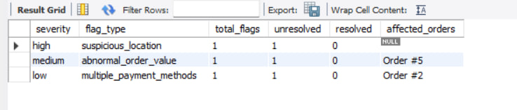
- Result: 3 anomaly flags detected — 1 high severity (suspicious driver location), 1 medium severity (abnormal order value on Order #5), and 1 low severity (multiple payment methods on Order #2). All currently unresolved.

Query 7 — Recommendation Engine
This query implements a collaborative filtering recommendation engine in SQL. It finds items ordered by customers with similar ordering patterns that the target customer has not yet tried, ranked by popularity and average food rating.
Recommendation Engine Result for Customer 1
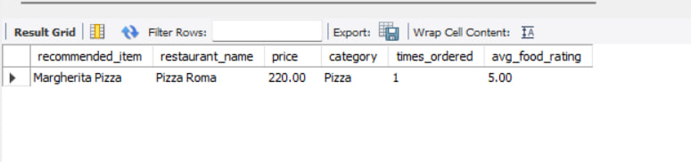

- Result: Margherita Pizza from Pizza Roma recommended for Customer 1 (Abebe Kebede) with a 5.00 average food rating. This item was popular with customers who ordered from the same restaurants as Customer 1 but has not been ordered by Customer 1 yet.

3.6 Implementation Summary
The QuickBite database system was successfully implemented in MySQL with all planned features working correctly. The following table summarizes what was implemented and tested:
- 17 MySQL tables created with proper constraints, primary keys and foreign keys
- 4 database views for order summary, prediction accuracy, restaurant performance and driver performance
- 3 stored procedures for driver assignment scoring, delivery prediction and anomaly detection
- 3 triggers for automatic loyalty points, driver rating updates and loyalty tier upgrades
- 7 advanced analytical queries including window functions, subqueries and CASE statements
- 4 MongoDB collections for menu catalog, order snapshots, customer reviews and driver activity logs
All source code is available in the project GitHub repository. The complete schema.sql, queries.sql, collections.json and queries.js files are organized in the /mysql and /mongodb folders respectively.

